

**SHIVAJI UNIVERSITY,KOLHAPUR**

**DEPARTMENT OF COMPUTER SCIENCE**

**(MCA Part III)**

#### A PROJECT REPORT ON

***“Mess Management System”***

#### SUBMITTED BY

**Miss. Petkar Pooja Anant**

**UNDER THE GUIDANCE OF**

**Dr. Mrs. S.V.Katkar**

**SHIVAJI UNIVERSITY, KOLHAPUR.**

YEAR 2020-2021



**SHIVAJI UNIVERSITY,KOLHAPUR**

**CERTIFICATE**

**DEPARTMENT OF COMPUTER SCIENCE**

**(MCA. Part-III)**

**Date:- 7 - 8 -2021**

This is to certify that partial fulfillment of curriculum of T.Y. MCA.

Student **Ms. Pooja Anant Petkar** has successfully completed the project working the Computer Science entitled **“Mess Management System”** prescribed by the **SHIVAJI UNIVERSITY, KOLHAPUR** and this project report represents his bonafied work in year **2020-2021.**

**PROJECT GUIDE EXAMINER HEAD,**

**Dept. of MCA(Computer)**

**ACKNOWLEDGEMENT**

I take this gracious opportunity to present my training work done at Earth LogicWare Technologies. The Training period of six months was an enriching experience for me from professional as well as personal front getting an opportunity to familiarize myself to the industry.

First and foremost, I would like to thank my project manager for having faith in me and giving an opportunity to work in their organisation.

I also wish to express my profound gratitude to Mrs. Dr. S.V.Katkar my guide for his precious guidance through my training and presentation work.

I am thankful to entire team of Earth LogicWare Techonolgies, who helped & guided me during the training period.

I am also obliged to all faculty members of Department of Technology, Kolhapur and my colleagues for their valuable suggestions and co-operation.

**Ms. Pooja Anant Petkar**

MCA - Part-III

**Index**

**Sr. No Title Page No**

1. Company Profile..............................................................................................1
2. Introduction.....................................................................................................7
3. Requirement Analysis& Proposed System ....................................................18
4. Process Model .……........................................................................................21
5. Design Features of System..............................................................................33
6. Implementation ................................................................................................59
7. Evaluation ........................................................................................................62
8. Future Scope& Advantages ….………………………………………………67
9. Conclusion ……………………………………………………………………70
10. References .……………………………………………………………………71

**CHAPTER 1**

**COMPANY PROFILE**

* 1. **Introduction**

“Earth LogicWare Technologies” has a vision to improve our customers business by thoroughly analyzing their needs and implementing cutting-edge web and software solutions, proving to be creative, reliable and cost-effective. Management Information for the purpose of Planning, Co-ordination, Execution and Performance Evaluation has been our prime objective of developing Computer Systems. The success of the implementation of various Systems designed for various functions in different organizations have directly resulted in improved operational efficiency, smooth flow of work, Reduced cost of manpower and ultimate profitability of the organization. Understanding precisely the functional requirements and providing a complete solution with simplicity in operation has been the key to our success.

**1.2 Vision and Mission:**

**Vision:**

To improve our customers business by thoroughly analyzing their needs and

Implementing cutting-edge web and software solutions, proving to be creative, reliable and cost-effective.

**Mission:**

Our mission is to build partnership with our customers, thus enabling their success by shipping them stable custom web and software solutions of consistent high quality and at a reasonable cost. In addition, we strive to constantly expand and continuously improve our services, capabilities and products.

**Our Team:**

**Technology Experts:**

We employ IT professionals who embrace Technology as part of their everyday lives. These specialists are highly experienced in their technical fields and are passionate about solving your complex business needs using a wide range of technologies.

**Our Team Members are:**

▪ Masters in Business Administration

▪ Masters of Computer Applications

▪ Masters of Computer Management

▪ Bachelors of Engineering

▪ Bachelors of Science in Computer Technology

▪ Bachelors of Computer Applications

**Software Development Skill Set:**

“Earth LogicWare Technologies” Team is a dedicated pool of IT Professionals equipped with strong knowledge, rich experience and sound logic. This blend comes from diverse backgrounds, education in leading technical institutes, and track records from associations with leading IT companies.

“Earth LogicWare Technologies” covers all major modern technologies, Computer languages and tools. Every member of our team has strong knowledge of definite skills set. As a result each member is Professional in their field.

**Programming language**

▪ PHP

▪ JAVASCRIPT

▪ JQUERY

▪ HTML

▪ CSS

▪ Android

**Database / RDBMS**

▪ Microsoft Access

▪ SQL

▪ My SQL

▪ MS SQL Server

**Operating systems**

Windows

**Software Solutions:**

▪ Application development and maintenance

▪ Customized Software Solutions

▪ System Testing and Debugging

▪ Database Solutions

▪ Application Migration

▪ Cloud Computing

▪ User Training

▪ Reverse Engineering

▪ Enterprise Application

▪ Quality Assurance Testing

**On-Site Development**

▪ Development at the Client side with testing

▪ Providing Technical Support

**Key Features:**

▪ Time Management

▪ Market Research and Analysis

▪ Quality of Work

▪ Extremely Reliable Approach

▪ Innovation

▪ Balanced Use of Technologies

▪ Self-Explanatory Report Generation

▪ Available 24 hours a Day and 7 days a Week

▪ Best Affordable Price

**Programming Languages/Technologies: Training**

• PHP ,HTML,CSS, JAVASCRIPT, JQUERY

The PHP ,HTML, CSS ,JavaScript training program from Earth LogicWare Technologies has a broad scope ranging from fundamentals to advanced programming. This course is the basic entry point for a career in software.

**Contact Information:**

Address:

1307, B-ward opp, Shingoshi Market, Mangalwar Peth, Kolhapur.

Email:**earthlogitech@gmail.com**

**CHAPTER 2**

**INTRODUCTION**

**2.1 Abstract:**

The main aim of any mess is to provide clean and fresh food to the students of the organization. In many organizations, entire mess management and billing calculations are done manually till date. It is very time consuming and increases the chances of performing calculation mistakes. It would be possible to do the same work within a short period of time and without using much efforts and manpower if there existed an application for the same. Thus, there arises a need to create an application for the same. Such an application would make the entire Mess related management an automated system. The application is not only restricted to food items and their billing manipulations, but handling the information of the Student is also possible in the software. Thus, such a combination in a single application is of great benefits. The product is an android application used to manage daily mess attendance along with streamlining rebate and menu selection processes.

**2.2 Introduction:**

* For simplicity and better understanding of the mess manager, this software is designed in multi-language. It would avoid confusion and help operate the software easily. Also, such a application that is easy to use will reduce the work of mess managers who still maintain all the logs in registers and files. It would be of great benefit as all calculations would be done easily on the click of a button.
* This software system will be a mess management system which consists of two separate software’s, one to be used by the students who eat in the mess and one for the mess administrator. The student software allows students to login and choose the monthly mess option, place orders for the night canteen online, book the mess for special occasions, view the daily mess menu and the night canteen (NC) menu, view food consumption statistics, inform the mess authorities when he/she won't be eating in the mess and submit feedback. The admin software will allow the mess administrator to make changes to the daily mess menu, upload food consumption statistics and view net profit, view orders for the night mess and approve any special lunch orders as well along with reading feedback. The system will utilize a relational database for handling all the data such as menu items, prices, student IDs, consumption statistics, student feedback, etc.
* Mess management system is really helpful for top level management in making decisions at different levels. Some of the academic institution which has mess facility are running their mess with manual process. To eliminate manual mistakes and time consumption the mess management application serves a better way. The accountability in all aspects is achieved through application which is not so accurate in manual system. Mess management application is engaged in providing up to date information about the details of mess students and stock availability. The student authentication is provided through SMS service. It includes option such as adding, deleting information about the students and stock items. The delete option is applicable to a single record or multiple. It also has a facility to print the status of status during a certain period. The other feature of this project is to provide hard copy of the total stock consumed during a given period. This project usage has scope at academic institutions.
* The application effectively manages the mess halls. The system allows users to access and mark their attendance through this app. It also enables customers to select dishes from the available menu of the day. The menu will be decided on the choice of the customer. The customer will mark their choice of dishes for upcoming days and the mess manager will provide the dish based on the customers' selection. The app has the functionality which allow user to mark attendance and select the menu before 4 hours of the opening time of mess. By taking the attendance there will be less wastage of food and the mess managers can manage the mess in a better way with the staff. The app also gives the notification to the user for attendance. This app also provide feature of maintaining attendance for staff. The app also has different features for both customers and managers. The manager will be the admin of the app and have access to set today’s menu and see today’s attendance i.e. the number of customers who are coming to mess. The managers also have the functionality to set future menu for upcoming days and customers vote for the upcoming menu which should be good for all customers. We believe that the technology can give this type of facility effectively and helps to reduce food wastage.

**2.3 Literature Survey:**

* The overall goal of this project was to firstly study and understand the existing mess management software, then identify the limitations and contribute in the same topic with greater benefits. The main advantage of our proposed system over other existing systems is the GUI in Simple English language. This has enabled complete understanding and convenience for the user. Also, complex calculations are done within seconds and bills are generated on the single click of a button. As the name suggests, it is a software for maintaining any mess but it also enables handling of the information related to the students/employees who are a part of the organization. Another attractive feature in our software which is lacking in the existing software is the Backup and Recovery option. All data can be stored as a copy, that is, taking backup is also possible on a single click, plus recovery of lost data in case any failure occurs is also possible on a single click.
* Mess Management System will help small business owner to manage their business. This project is developed for Hostel Mess Management System**.** Much such software is available in market but they are tedious and complicated with complicated user interface. But Mess Management System is web based application so we can provide very user friendly UI which is easy to understand and manage. The approach/model used for developing software depends on the kind of system we want to develop. We analyzed the requirements thoroughly first and then spent lots of time in System Designing. But when we went for implementing the desired system, we realized some shortcomings in the design and had to revise the design again. We aimed at following waterfall model but finished up using Modified waterfall Model.
* While making design of the system emphasis was put on having an efficient modular design. It has been implemented during implementation phase by taking care of basic things which ensure effective modular design. Software testing is a very critical element of software quality assurance and represents the ultimate reviews of specification, design and coding.
* The online food ordering system is easy for the student. It overcomes the disadvantages of the traditional queuing system. This proposed system is a medium to order online food conflict free from mess service. This system improves the method of taking the order from the student. The online food ordering system sets up a food menu online and students can easily place the order as per their wish. Also with a food menu, students can easily track the orders. This system also provides a feedback system in which a user can rate the food items. Also, this system can recommend hotels, food, based on the ratings given by the user, the hotel staff will be informed for the improvements along with the quality. The payment can be made online or pay-on-delivery system. For more secured ordering separate accounts are maintained for each user by providing them an ID and a password.
* A system is based on student needs. The system is developed to considering the issues related to all students who are included in this system. The wide range of people can use this if they know how to operate an android smartphone. Various issues related to Mess Service will be solved by providing them a full-fledged system. Thus, the implementation of the online mess management system is done to help and solve one of the important problems of people. Based on the result of this research is it helps a student in making order easily It gives the information needed in making the order to a student of mess service providers with their food style, which will be fulfilled using our application. This system helps to give more priority to mess service and enrich their growth from their current fading situation. The reason to develop the system is due to the issues facing the food industry. The challenges encountered by the existing system serve as a major drawback to the realization of efficiency and student satisfaction. This application will contain different types of food varieties available for the user. The system also allows to quickly and easily managing online menu which students can browse and also predict how much is spend on food, and use to place orders with just a few clicks. The main aim is to increase efficiency and improve services provided to the students through better application of technology in daily operations. The disadvantages of the paper-based system are that papers can get easily damaged by stain marks they can be lost due to fire or accidents or can get lost in general. Hence, time and money are wasted. This system is very Time consuming, lack of visual confirmation that the order was placed correctly.
* Testing represents an interesting anomaly for the software. Testing is vital to the success of the system. Errors can be injected at any stage during development. System testing makes a logical assumption that all the parts of the system are correct; the goal will be successfully achieved. During testing, the program to be tested is executed with a set of test data and the output of the program for the test data is evaluated to determine if the program is performing as expected.
* We have seen over the years that the process of manual attendance has been carried out across almost all educational institutions. The process is not only time consuming but also sometimes inefficient resulting in the false marking of attendance. Today, we need not maintain a pen and paper-based attendance registers. Following this thought, we have proposed an attendance marking and calculation system which is implemented on application that communicates with the database. This application will give the students information on attendance.

**2.4 Choice of the topic with reasoning:**

The Challenges encountered by the manual system in mess is efficiency and student satisfaction. The experience of ordering in most fast food mess is not pleasant for students. Students have to make long queues before placing the order and when the order is placed they have to wait near the counter until the order is prepared. The another problem is efficiency that food mess should maintain in their standard operations and keep with the quality of their product and services no matter how much crowd is present in mess but they have to maintain efficiency as well as quality of product .however, we think that there are some issue concerning the traditional way to order food in mess.

**2.5 Objectives:**

* Mess management system will able to provide fast services to their students by using their records which has been saved previously. However new records can be added any time whenever any student visited to their mess. To identify the Students, each student will be provided with their student id and during data entering process all their basic information’s will be added into the database.
* Each student will be provided with a unique number by which system will easily able to identify their students and prepare their bills for the services which they have taken. It will also help the mess’s admin to identify such students whose payment has not been cleared till date.
* Admin will have the facility what are the items which are available at their mess at particular time and what is the exact quantity of any particular item. As students will also able to check their account status, services which they have taken and bills which they paid and due amount details, if there is any for their account. Details section will also make their students updated regarding business hours of the mess.

**2.6 Feasibility Study:**

A procedure that identifies, describes, and evaluates candidate systems and selects the best system for the job is called as Feasibility study.

Once the scope of the project had been defined, it was reasonable to ask: “Can we build system to meet this scope? Is the project feasible?” Our feasibility study focused more on the cost, efforts and resources required for the system.

Software feasibility is based on four solid dimensions, which were taken into consideration before moving ahead:

Three key considerations are involved in the feasibility analysis:

1. Technical Feasibility
2. Economic Feasibility
3. Operational Feasibility

**1. Technical Feasibility:-**

Technological feasibility is carried out to determine whether the company has the capability, in terms of software, hardware, personnel and expertise, to handle the completion of the project when writing a feasibility report.

The proposed system can be implemented with some existence technology. The company is already having the hardware and software required for proposed system. The company already has a Local Area Network (LAN). The proposed application will be installed on the server and the interfaces, resources and related data of the proposed system will be shared to all workstation. The workstations will be connected to the server to all workstation. The workstation will be connection to the server over the network so that all users are able to share the application's resources and work individually. Thus it can be found that the proposed system is technically feasible.

**2. Economic Feasibility:-**

Cost benefit analysis is very important in deciding whether the project is economically feasible or not. It is alone sufficient to save our time and money. It is one time investment and does not require regular maintenance. Through cost benefit analysis it was concluded that the benefits outweigh costs and thus the project is economically feasible.

As the development work for the system going on smoothly as was planned during the project-planning phase and the company had licensed copies of the software’s required for the development of the project and hence need not pay any additional cost for the same and hence the system is economically feasible.

**3.** Behavioral Feasibility**:-**

Behavioral feasibility determines how much effort will go into educating, selling and training the user staff on a candidate system. The project was also evaluated to be behaviorally feasible as it is very user-friendly and hardly needs any extra efforts to educate user for its utility and functioning.

**3.** Time Feasibility**:-**

The development work for this software is running under the specified time period there was no need for extra resource for the development and hence the system is timely feasible.

**2.7 Present System in use:**

The present system uses manual register entry. Hence there is a need to create a dynamic website.

* System can be web-based so that every mess’s member can easily interact with system.
* System can provide optimize functionality.
* System can be flexible enough so that it can incorporate different changes time to time.
* The most important thing is security. All the data should remain consistent and secure.

**CHAPTER 3**

**REQUIREMENT ANALYSIS & PROPOSED SYSTEM**

**3.1 Software Requirement Specification:**

Administrator wants to build the system that technically and economically strong and helpful to company progress. He wants to reduce large man-power involved in company to perform the task that high company cost and slow company work. For future use all documents are kept in written or in a file in secure manner. If a file gets lost it cannot be retrieved in any way. A large storing area is required to store the data manually.

The purpose of software requirements specifications is to provide a framework that enables the admin to take reasonable estimates of resources, cost and schedule. These estimates are made with a limited time frame at the beginning of a software project and should be updated regularly as the project progresses. In addition estimates should attempt to define best case and worst case scenarios so that project outcomes can be bounded.

To gather the requirement of client’s need, we take the idea about the data flow from other websites and also refer documents.

**3.2 Flaws in present System / Need for new system:**

* Present system is a totally manual system which lacks security, with lengthy process and is time consuming. This is not user friendly
* The data is recorded manually using pen & paper, which is error prone and often, leads to confusion& chances of wrong data filling.
* A lot of file work had to be done for storing information like member details, sale details, stock details, events etc.
* There may be possibility of delay in managing accounting process like generate billing.
* Also certain information redundancy may occur then it will become a hurdle to manage.

**3.3 Proposed System:**

* The purpose of this application is to automatize the mess functionality and provide both the user and the admin a smart platform to interact with each other.
* To use this facility, the User has to register and with the account credentials he can login the account and get connected to the network. Once connected the user can use the functionalities of the mess such as accessing his account information, applying for leave and checking the menu.
* On the other hand, the admin can log on and check the inventory details and also get to know the number of guests visiting the mess that day. This application aims at providing ease to both the users and the admin.
* The product is an android application used to manage daily mess attendance along with streamlining rebate and menu selection processes. Objective of the system is to provide a user friendly daily attendance system that is easy to manage, maintain and query. Our primary focus is to develop a paperless system that provides the management a way to facilitate smoother functioning of the mess system.
* We propose a system that will make the entire mess management an automated system. The important features of the proposed system are as follows:
  + The software will be made in English language. For security reasons, a Login feature will be provided so that only the mess manger can operate the software. Facility to change the password will also be available.
  + The system will also contain facility for manipulating the information of students as well as generate their bills based on number of meals they have consumed.

**CHAPTER 4**

**PROCESS MODEL**

* 1. **Software development Life Cycle:**

Software Development Life Cycle (SDLC) is a process used to conceptualize, design and develop high-quality software solutions that meet customer expectations and are delivered within predefined time and cost estimates.

SDLC is important because it breaks down the entire life cycle of software development thus making it easier to evaluate each part and guarantee its successful execution.

The Software Development Life Cycle has 7 phases that govern each step of the software development process from planning to development, to testing and from deployment to maintenance.

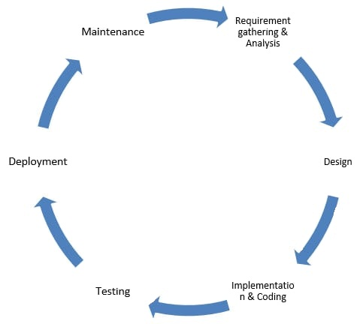

Phase 0: Validation and Concept Development

The first (actually zero) step is to validate the need for the software that you/your client want to create and develop a high-level (vague) concept of it.

* Validation = solves a problem? + Need?
* Software concept = what? + How it’ll solve the problem?

### Phase 1: Planning

The Software Development Life Cycle (also known as Loop) begins with a “Planning” phase. In the “Planning” phase we take the validated concept from Phase 0. And draw its outlines – features, screens/web pages, and test whether it is all possible to achieve.

The goal of the planning stage is to roughly define our software and to execute a feasibility study (to check whether it’s achievable) in the following areas – technical, operational, financial, human resources, legal/political.

It’s technically possible to implement that feature and User Interface given that we have a large enough training dataset for the machine learning algorithm.

To operate and maintain the software we’ll need a cloud infrastructure for the servers, data science team to ensure the algorithm’s accuracy and a small customer support team to nurture the users.

### Phase 2: Requirements Definition & Analysis

After the planning is done, it’s time to define and analyze the requirements of the software. This is the most important (but also most boring) step of SDLC and also for that reasons usually, the most skipped one.

The goal of the “Requirements Definition & Analysis” is to grab everything from the planning phase to research and to document it in detail. In this phase, we’ll summon our technical, financial, legal, sales/marketing, and design teams to leverage their domain expertise on the software “outline” we just created in the Planning phase.

The Requirements Definition & Analysis is a usually long process that consists of multiple meetings. In between those meetings domain experts (tech, financial, legal, consultants) will research and define strict requirements for the software.

After the requirements are defined and carefully analyzed the Product Manager/Owner will create an SRS (Software Requirement Specification) document. This process could be done with the help of software,

At this stage, the customer and the Product Owner must have agreed on the SRS which describes all the requirements that we’ll be developed and designed during the software development lifecycle.

When the Product Owner receives a green light from the customer they’ll create tickets in a project management system. Once tickets are created its time to start the real work.

Phase 3: System Design

The “System Design” phase of SDLC takes all the requirements from Phase 2. and assigns domain experts to each of them so they can start designing a solution for that requirement.

The goal of the “Design” phase is to create an actionable plan for each defined requirement that will be implemented later. In this phase, each team will grab the tickets from the project management software and start working on them. Here’s what different teams might be doing in the design phase:

* **Design team** – create UI/UX wireframes for the software, pick up brand colors & theme
* **Tech team** – choose the Technical Stack and the Application Architecture, create Database models
* **Business team** – define Business rules and logic
* **Sales & Marketing team** – define Buyer Personas, Prospect Fit Matrix, Buyer’s Journey, and plan a growth strategy

Phase 4: Development/Implementation

The “Development” (also known as the “Implementation” ) phase is associated with the execution of the planned tasks in the Design phase.

This is the longest phase of the SDLC model where each team will get their hands dirty and implement the solution that they’ve designed.

The goal of the “Development” phase is to deliver a software system that meets all the requirements defined by the client.

Here’s a list of tasks different teams might do in Phase 4. of the SDLC:

* **Operations team** – set up the project: dev environment, version control (e.g. GIT), server machines, infrastructure in general
* **Developers** – start to code and implement the product
* **Designers** – turn the Wireframes from Phase 3. to beautiful product design
* **QA team** – develop test cases and prepare a test plan to cover all the requirements

### Phase 5: Integration & Testing

The “Integration & Testing” phase of the SDLC is devoted to ensuring that the “Implemented” software from the Development phase meets all customer requirements, works as expected, and doesn’t have bugs.

The goal of Phase 5 is to provide end-to-end integrated software that will be carefully tested and continuously updated/fixed to ensure the best quality possible.

A common myth is that only QAs are involved in the testing phase but in reality that’s a responsibility for every member of the project.

1. **DevOps (developer + operations)** – integrate servers, databases, systems together to work with real data (so the software can be tested end-to-end)
2. **QA** – execute test plans and raise bugs in the project management software
3. **Designers** – run usability tests, ensure the design looks good on all resolutions and displays
4. **Business team** – ensure business rules are effective
5. **Developers** – fix bugs, update the UI, code additional features/business logic
6. **Legal team** – ensures the software implementation is compliant with all laws and regulations
7. **Client** – approves the final version of the software

### Phase 6: Deployment (Release)

The “Deployment” phase of SDLC is to configure all software systems and servers to work on production, make final tests, execute a release checklist and deploy the software.

The goal of deployment is to deploy the already tested and verified to work as expected in a real-world production environment while meeting all customer requirements and expectations.

Although the most involved in the deployment process are DevOps and QAs, the whole company is responsible and has tasks in this final crucial phase. Here’s a list of things that you might want to check before deploying your software:

* Staging servers & databases => configured for production
* Security rules: make sure that your server security rules are not configured for testing
* Third-party systems: switched from staging to prod.
* Validate: links, email, privacy policies, URLs
* Software empty states: what happens when the user has no saved data and runs the software for the first time?
* Software translations & location settings.

This checklist contains some of the important things to check before releasing your software but keep in mind that it isn’t completed since every software has different requirements.

The final part of the “Deployment” stage of SDLC is the Marketing team to execute a pre-planned product launch when it’s verified that the software is stable in production.

### Phase 7: Maintenance

The last phase of the Software Development Life Cycle is “Maintenance”. In that pha0se, the software is released and real customers are already using it. The goal of “Maintenance” is to support those customers and to ensure that the software is working as expected in the long run.

The large majority of the “Maintenance” phase is handled by customer support and tech support teams – developers with admin access, who can reconfigure broken parts of the software or fix bugs.

The key activities in the last phase of SDLC usually include:

* Customer support
* Monitoring servers
* Fixing uncaught bugs
* Fulfilling user requests that can’t be done through the UI

For that purpose, software companies usually also create a separate software application called “Admin panel” which allow the tech support to manage data.

* 1. **Software Model**

Spiral Model:

The spiral model combines the idea of iterative development with the systematic, controlled aspects of the waterfall model. This Spiral model is a combination of iterative development process model and sequential linear development model i.e. the waterfall model with a very high emphasis on risk analysis. It allows incremental releases of the product or incremental refinement through each iteration around the spiral.

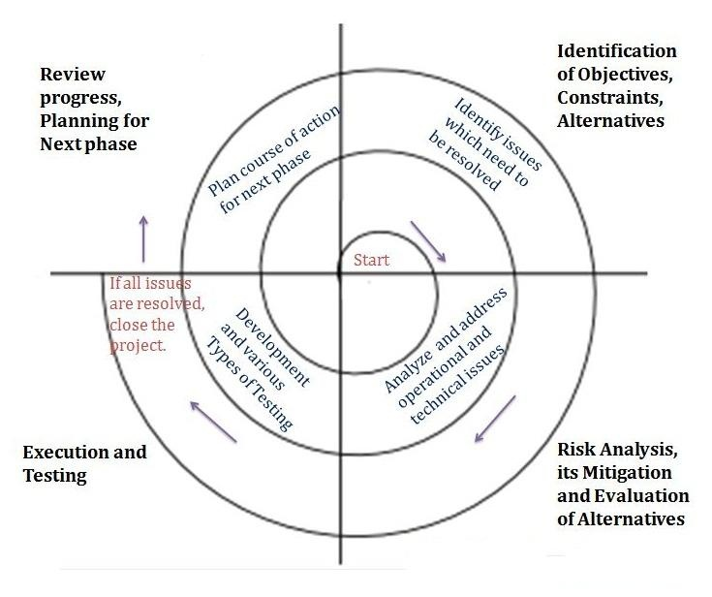

The spiral model has four phases. A software project repeatedly passes through these phases in iterations called Spirals.

### Identification

This phase starts with gathering the business requirements in the baseline spiral. In the subsequent spirals as the product matures, identification of system requirements, subsystem requirements and unit requirements are all done in this phase.

This phase also includes understanding the system requirements by continuous communication between the customer and the system analyst. At the end of the spiral, the product is deployed in the identified market.

### Design

The Design phase starts with the conceptual design in the baseline spiral and involves architectural design, logical design of modules, physical product design and the final design in the subsequent spirals.

### Construct or Build

The Construct phase refers to production of the actual software product at every spiral. In the baseline spiral, when the product is just thought of and the design is being developed a POC (Proof of Concept) is developed in this phase to get customer feedback.

Then in the subsequent spirals with higher clarity on requirements and design details a working model of the software called build is produced with a version number. These builds are sent to the customer for feedback.

### Evaluation and Risk Analysis

Risk Analysis includes identifying, estimating and monitoring the technical feasibility and management risks, such as schedule slippage and cost overrun. After testing the build, at the end of first iteration, the customer evaluates the software and provides feedback.

The following illustration is a representation of the Spiral Model, listing the activities in each phase.

**4.3 Modules and Modular Charts:**

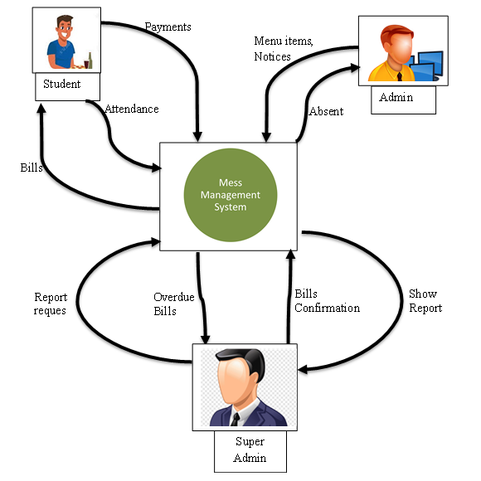

**4.4 Modules**

The architecture diagram of the system consists of major four modules. Student, mess management, administrator and mess secretary.

1. **Student module:**

The student module consists of all activities performed by student. Student performs following actions: -

* **Make Attendance:**

Student mention that he is attending a lunch/dinner or not. As our system provides the pre attendance system, the student can tell the admin at morning that he will present at the evening or not.

* **View Notices:**

Student can view the notices and give corresponding response. The notices would be about any occasion or in the case of mess closed.

* **View Menu:**

The student can view menu. Also we are providing the options for student that he can choose any one menu for that particular shift (morning/evening) and do voting for it.

* **Update Profile:**

Student can update his profile. In this module student can change his password, profile picture, or any other updates.

1. **Admin Module**

Admin is the person who handles and manages the whole system. Admin performs following functions:

* **Manage Student:**

The admin can manage student. In this module student addition, deletion, updating etc.

* **Menu:**

The administrator provides options of menu for student and as per voting of student menu will be selected by user

* **Notices:**

Administrator can generate notices about occasion, events or in the case of mess closed. Student can only view these notices.

* **Messages:**

Administrator can view birthdays of students and send them wishing message. He can also send occasion message.

* **Guest:**

Administrator views the requested guest and adds their food in that particular shift.

1. **Super Admin**

The Super Admin is owner of mess. He checks bill payments. Labors payments, required raw material.

* **Overdue Bills:**

The Super Admin checks bills if there are bills which are not paid by student then he can take an appropriate action.

* **Bill Confirmation:**

Administrator is responsible for providing the all reports. The bills provided by administrator are checked by secretary.

* **Supply needs:**

As the Super Admin is main in charge of accounts he is totally responsible for providing the needs required for mess.

1. **Mess Management Module**

The mess management system is nothing but the database in which all data is stored. It is server and central system. It provides requested data to user. It backup the deleted student’s data.

**CHAPTER 5**

**IMPLEMENTATION**

**5.1 Hardware &Software Requirements**

* **Server System (Minimum Configuration) :**
  + Processor: Pentium 3
  + RAM: Minimum 512 MB or above
  + Hard
  + Disk: 40GB
* **Client side**
* Processor: Dual Core
* RAM: Minimum 512 MB
* Hard Disk: atleast 40 GB
* **Software Specification:**
* Platform: Window XP, Window 7, Window 8
* Front End: HTML, CSS, JavaScript, android
* Back End: PHP, MySQL
* Browser: Internet explorer 8.0 and above, Mozilla Firefox, Google Chrome etc.

**5.2 Technology Used**

* **PHP:**

**PHP** is a general-purpose scripting language especially suited to web development. It was originally created by Danish-Canadian programmer RasmusLerdorf in 1994. The PHP reference implementation is now produced by The PHP Group. PHP originally stood for Personal Home Page, but it now stands for the recursive initialism *PHP: Hypertext Preprocessor*.

* + PHP is a recursive acronym for "PHP: Hypertext Preprocessor".
  + PHP is a server side scripting language that is embedded in HTML. It is used to manage dynamic content, databases, session tracking, even build entire e-commerce sites.
  + It is integrated with a number of popular databases, including MySQL, PostgreSQL, Oracle, Sybase, Informix, and Microsoft SQL Server.
  + PHP is pleasingly zippy in its execution, especially when compiled as an Apache module on the Unix side. The MySQL server, once started, executes even very complex queries with huge result sets in record-setting time.
  + PHP supports a large number of major protocols such as POP3, IMAP, and LDAP. PHP4 added support for Java and distributed object architectures (COM and CORBA), making n-tier development a possibility for the first time.
  + PHP is forgiving: PHP language tries to be as forgiving as possible.
  + PHP Syntax is C-Like.
* **HTML-CSS:**

HTML stands for Hypertext Mark-up Language, and it is the most widely used language to write Web Pages. Hypertext refers to the way in which Web pages (HTML documents) are linked together. Thus the link available on a webpage is called Hypertext. As its name suggests, HTML is a Mark-up Language which means you use HTML to simply ”mark up” a text document with tags that tell a Web browser how to structure it to display.

Cascading Style Sheets (CSS) is a style sheet language used for describing the presentation of a document written in a mark-up language. Although most often used to set the visual style of web pages and user interfaces written in HTML and XHTML, the language can be applied to any XML document, including plain XML, SVG, XUL, and is applicable to rendering in speech, or on other media. Along with HTML and JavaScript, CSS is a cornerstone technology used by most websites to create visually engaging web pages, user interfaces for web applications, and user interfaces for many mobile applications.

* **Apache:**

The Apache HTTP server is the world’s most used web server software. Apache supports a variety of features, many implemented as compiled modules that extend the core functionality. These can range from server-side programming language support to authentication schemes.

* **My-SQL:**

My-SQL is the world's most popular open-source database. With its proven performance, reliability and ease-of-use, MySQL has become the leading database choice for web-based applications. It is also open source. My-SQL is a fast, easy-to-use RDBMS being used for many small and big businesses. My-SQL is developed, marketed and supported by My-SQL AB, which is a Swedish company. My-SQL is becoming so popular because of many good reasons –

* My-SQL is released under an open-source license. So you have nothing to pay to use it.
* My-SQL is a very powerful program in its own right. It handles a large subset of the functionality of the most expensive and powerful database packages.
* My-SQL uses a standard form of the well-known SQL data language.

My-SQL works on many operating systems and with many languages including PHP, PERL, C, C++, JAVA, etc. MySQL is very friendly to PHP, the most appreciated language for web development

**5.3 System Design**

5.3.1 ER-Diagram

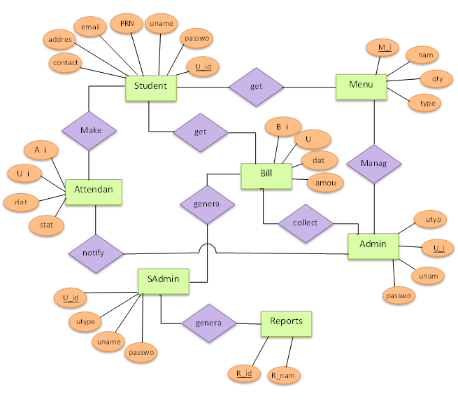

5.3.2 Use case (Student)

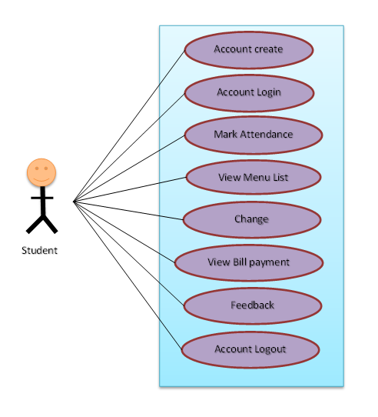

5.3.3 Use case (Admin)

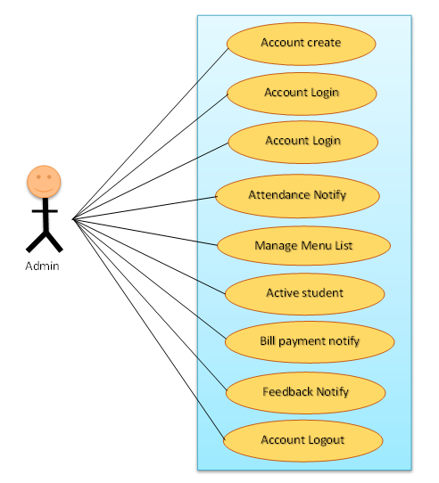

5.3.4 Use case (Super Admin)

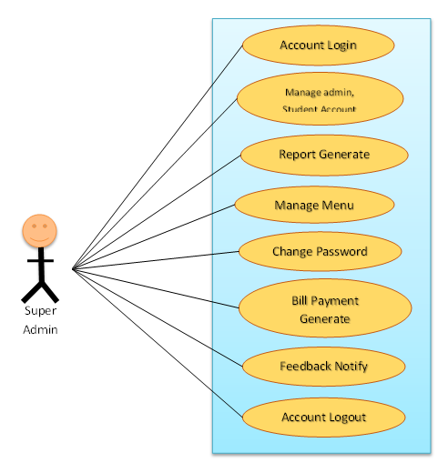

5.3.5 Sequence Diagram (Mark Attendance)

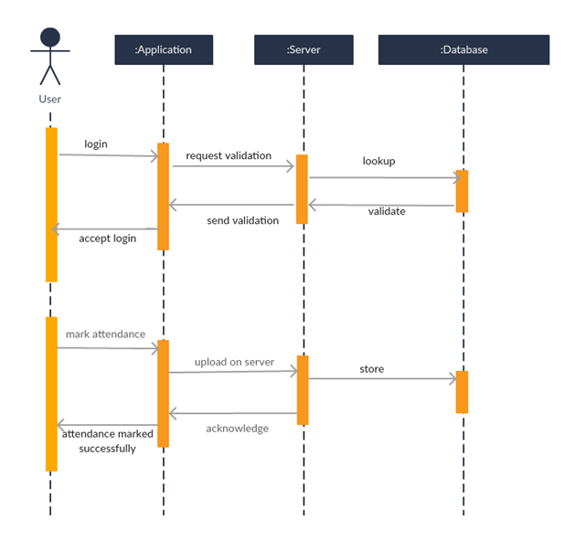

5.3.6 Sequence Diagram (Requesting rebate)

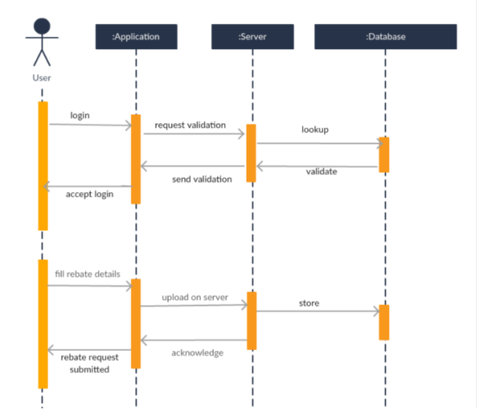

5.3.7 Sequence Diagram (feedback)

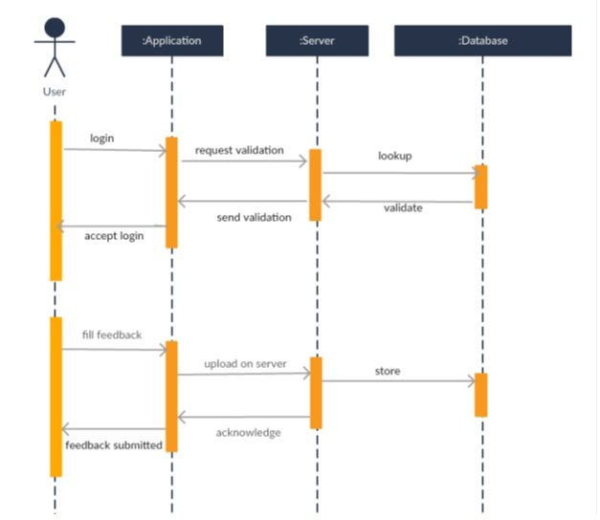

5.3.8 Sequence Diagram (Menu Selection)

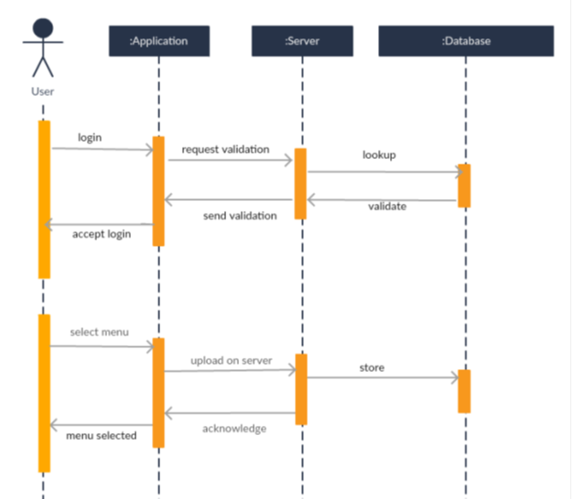

5.3.9 Class Diagram

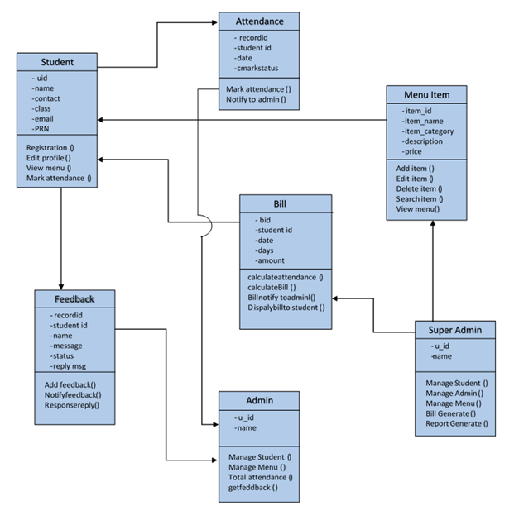

5.3.10 DFD (Zero level)

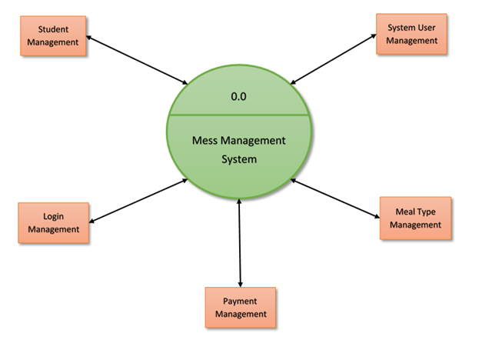

**5.4 Form Design**

5.4.1 Login Page:

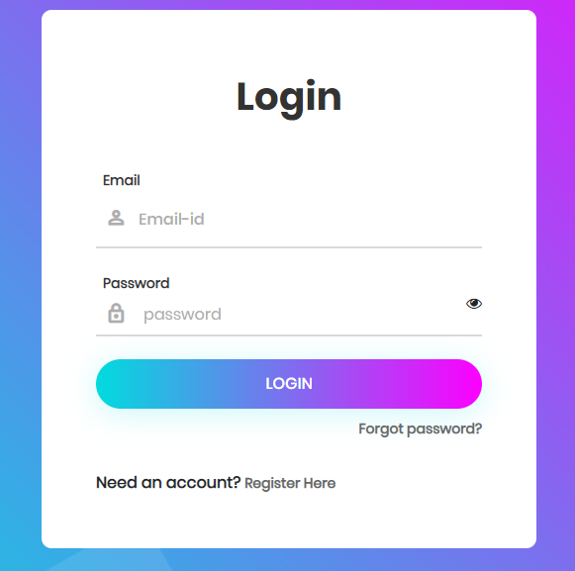

5.4.2 Student Registration Page:

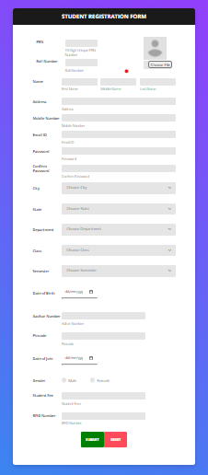

5.4.3.Admin Registration Form :

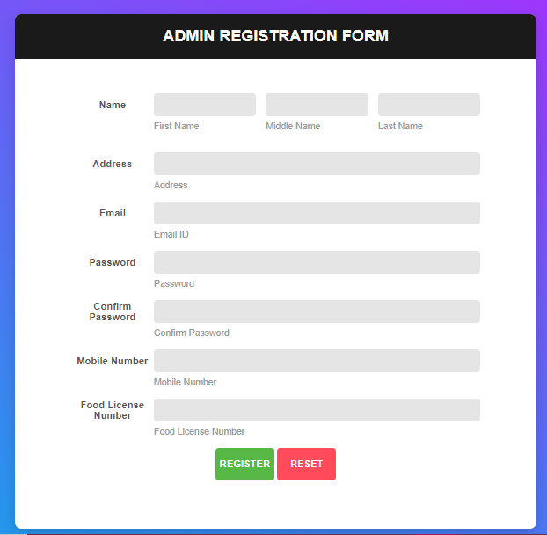

5.4.4.Super Admin Registration Form :

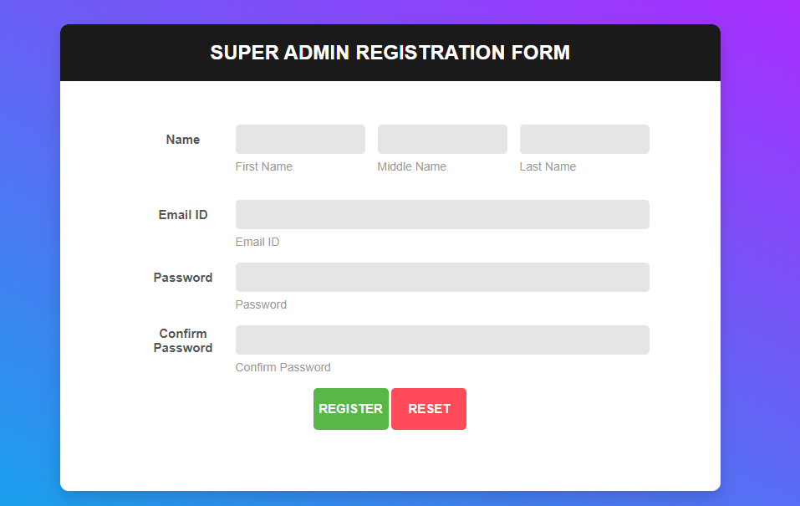

5.4.3 Reset Password:

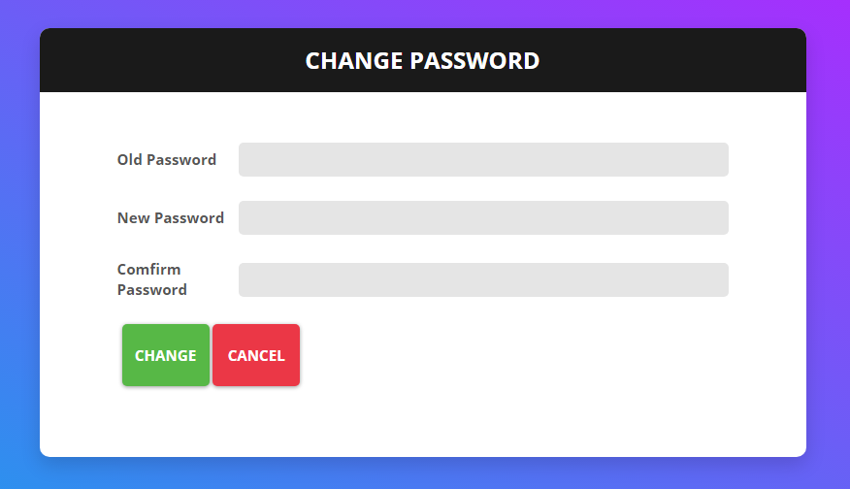

5.4.4 Student Dashboard:

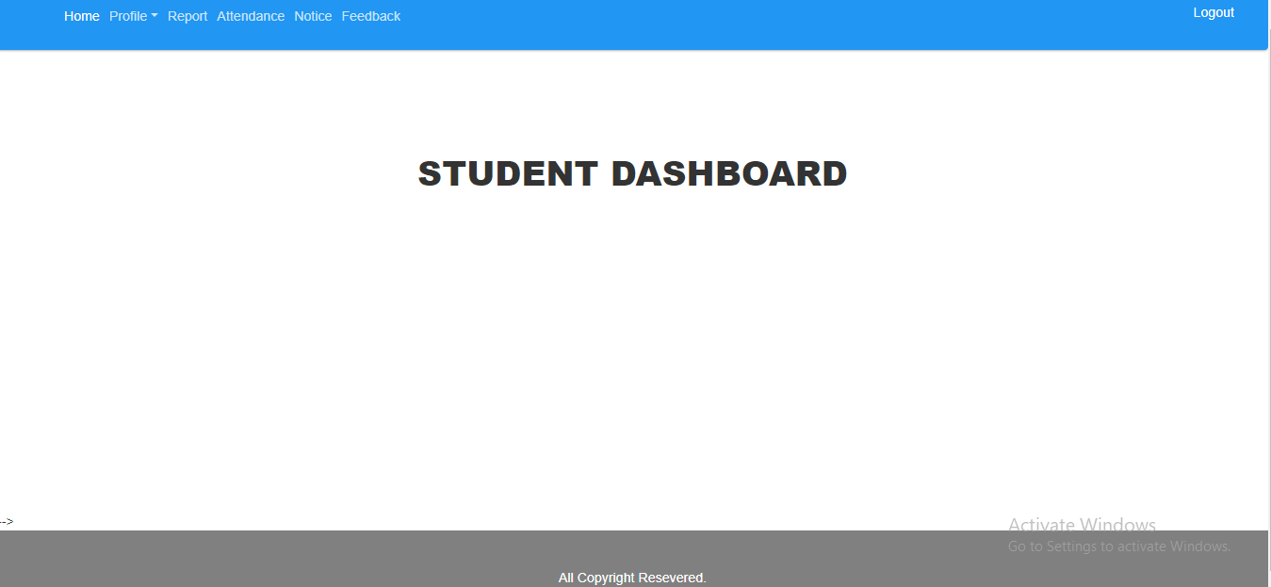

5.4.5 Admin Dashboard:

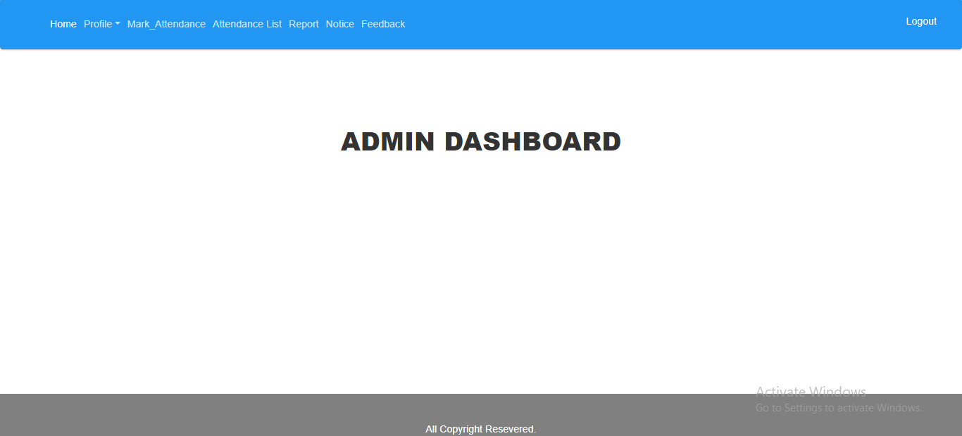

5.4.6 Super Admin Dashboard:

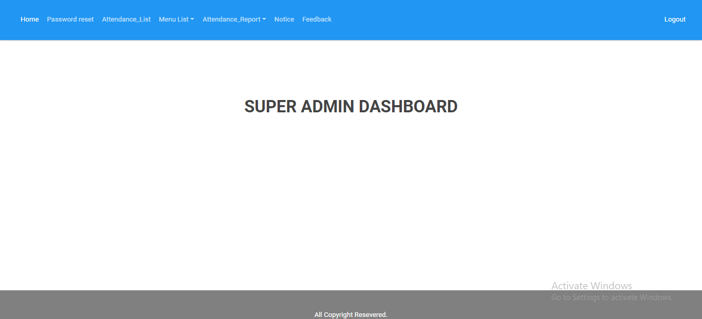

5.4.7 Feedback:

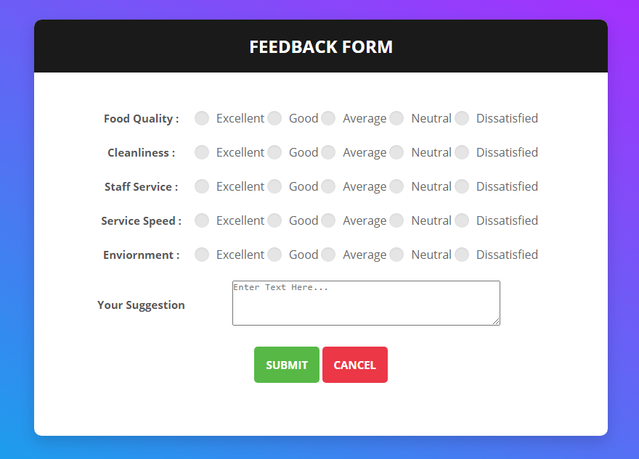

5.4.7 Notice:

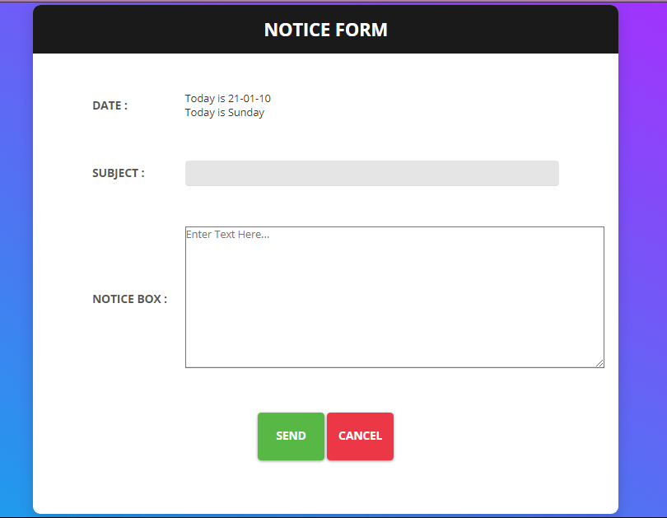

5.4.8 Complaint:

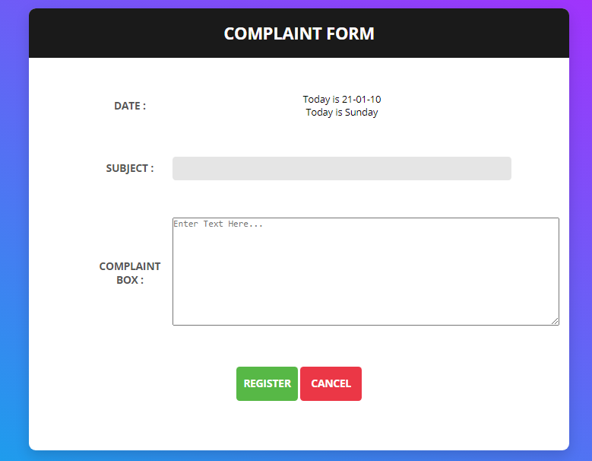

5.4.9 Feedback statistics for Admin and Super Admin :

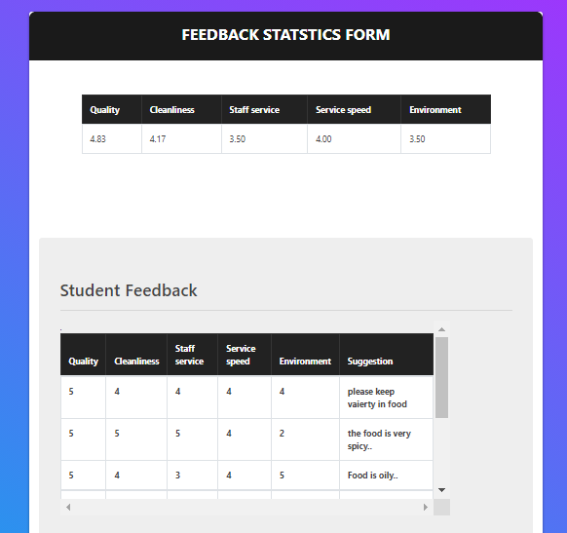

5.4.9 Attendance :

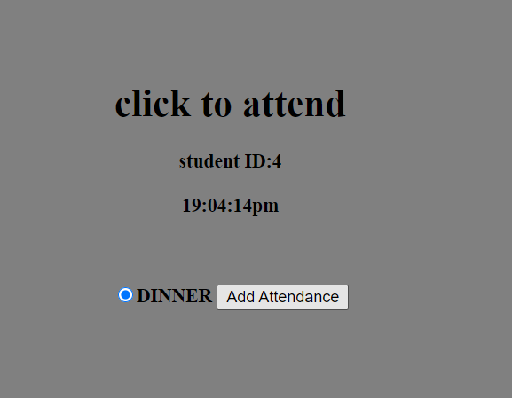

5.4.10 Update Food Price:

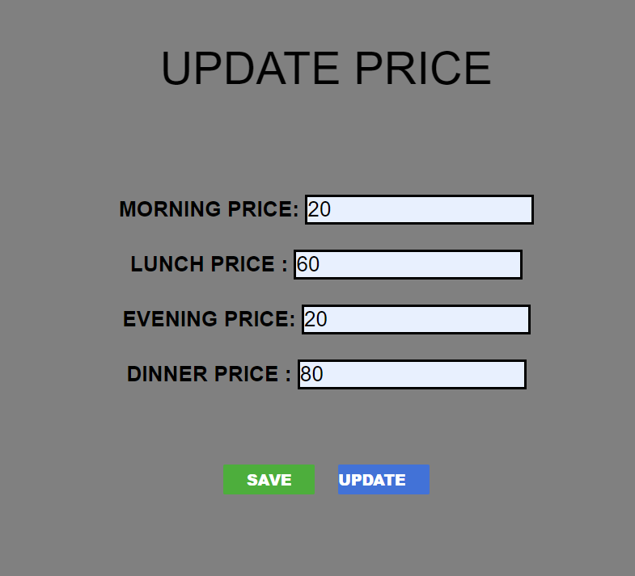

5.4.11 Student Daily Meal Report:

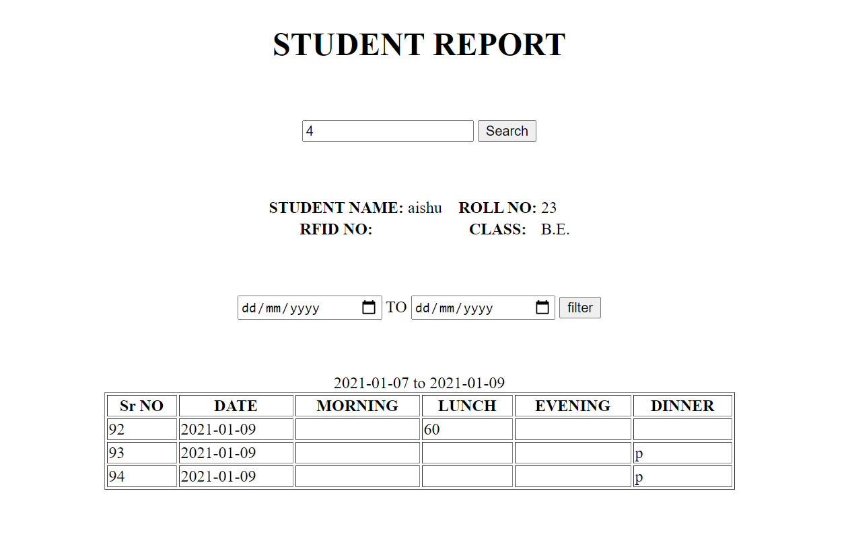

5.4.12.Student registration database :

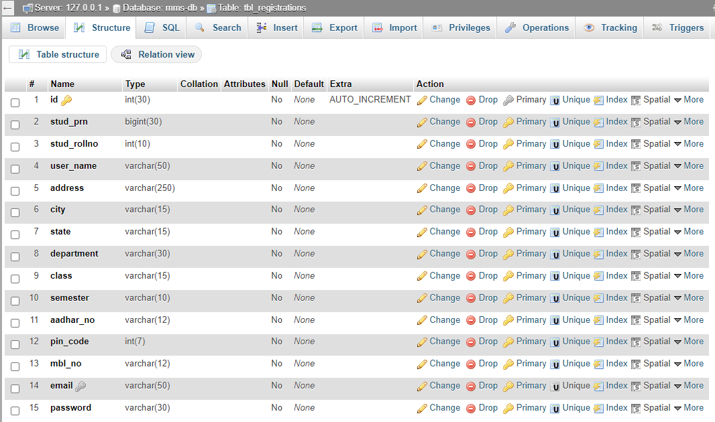

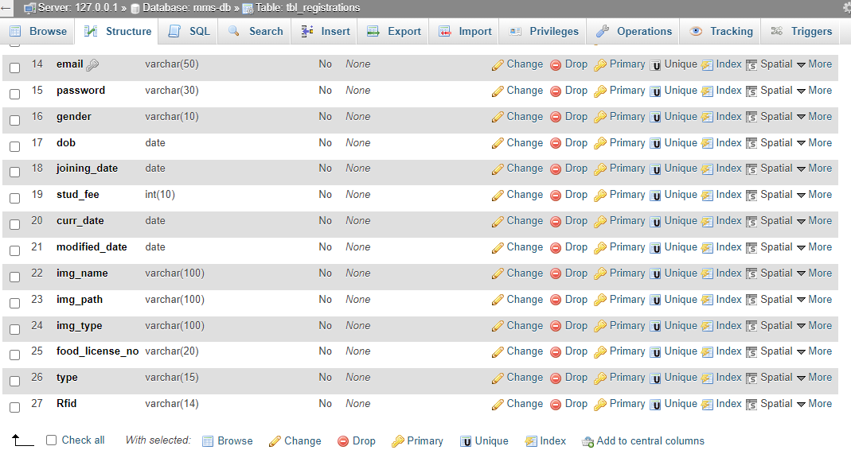

5.4.13Mess time database :

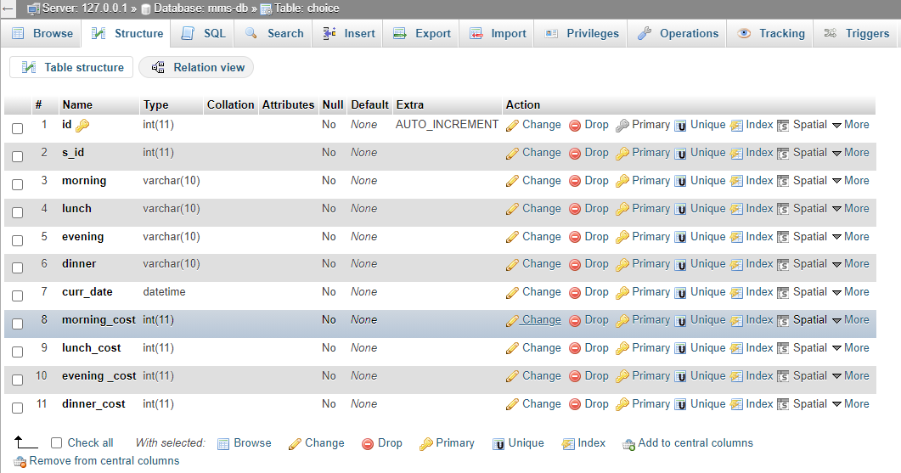

5.4.14.Feedback Database

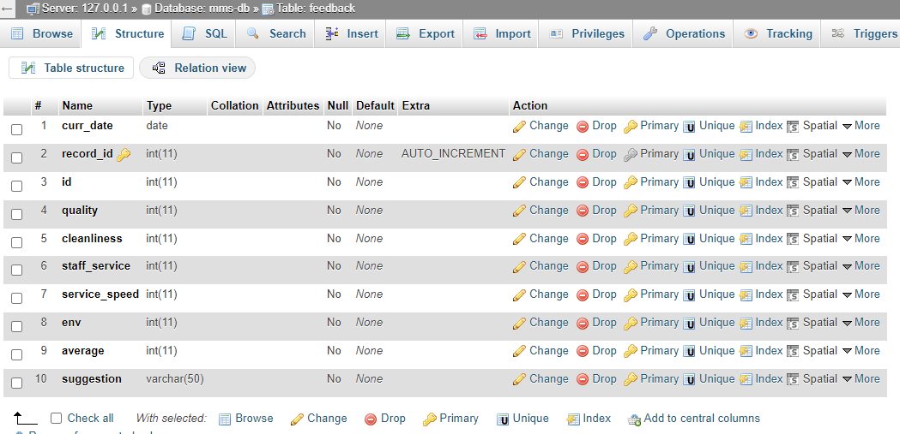

5.4.15Report table database :

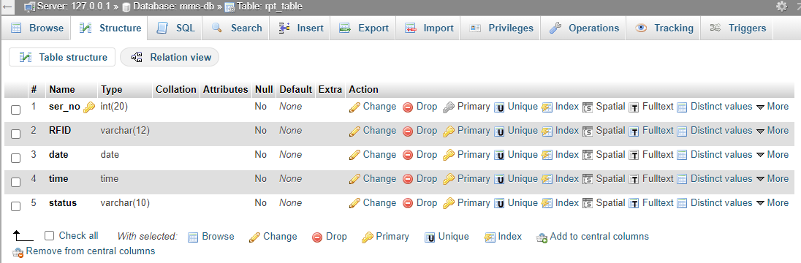

5.4.16.Menu price database :

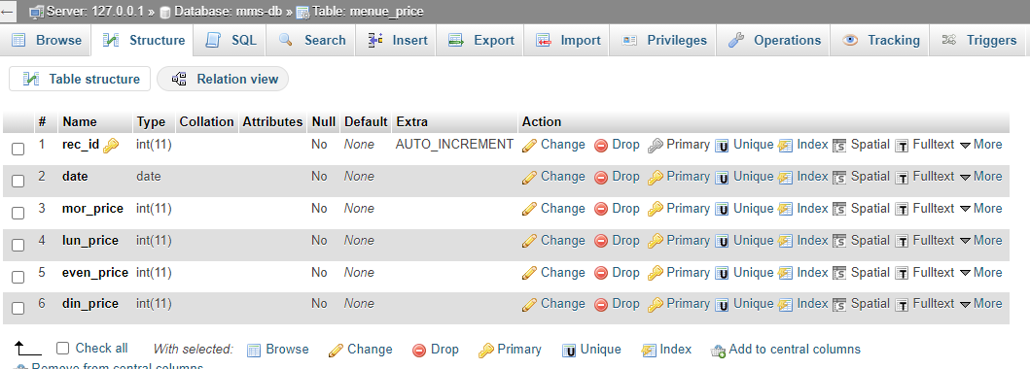

**5.5 Validation Checks**

Under validation we have provided certain constraints and primary keys to few fields of the tables of the database used in application. This validation made at database level is listed below:

* **Required Field Validation**: we use require field for fill the information compulsory in the project without this validation the data will not be submitted in the project.
* **Not null**: Not null constraint is used restrict field to have null values. Few fields in our database are mandatory to fill.
* **Numeric only**: Numeric only constraints restrict field to have numeric values only. Otherwise it violates the rule.
* **Character only**: It restricts the field to accept only character value.
* **Date:** The valid date with valid format should be enter in the given textbox.
* **Email:** The @ Symbol is required in this field otherwise it will not work properly.

**5.6 Result:**

The world of Internet has changed the pace at which the world normally used to work and now we can access multiple systems at a click or a touch of a screen. Online transaction for banks, shopping at e-commerce sites and booking travel tickets is now possible from the internet itself.

Keeping up to speed is the need of the hour in this fast paced environment for a student, so what better than accessing the whole of the mess system on one’s devices.

**CHAPTER 6**

**IMPLEMENTATION**

**6.1 Implementation:**

Domain Names: Based on requirement, we will need to pick out a Domain Name. While a domain name that uses words that summarize the site or services are good for administrator, which help us in deciding the domain name and getting it registered.

Hosting: We have to take a space on server for our files so the website would be access through internet.

**I. Site Category & Layout**:

The message to get across to the viewer quickly and easily. We have take the time to determine what’s the main theme or message is to be, then break that theme or message down into categories. Which will help guide us through this process and help determine a site format that loads?

**II. The Size Website:**

Normally it’s best to keep our first website to a minimum size. Not only is it less costly, but this allows administrator to grow as the web base clientele increases. We add, change and substitute new information, pages, links, and text as the business and site progresses. Starting with a basic website leaves the room to grow and change as the circumstance dictates.

**6.2 Testing**

There are various types of web application testing without which we cannot say that the complete system is properly working. Some of the most important web testing has been mentioned below:

* **Unit Testing:** Unit testing happens at the development level. When a developer builds a piece of code that delivers a set of functionality, they must test it to make sure it works and that it delivers the required functionality. A developer tests by running the code in their own environment. A piece of code (be it a web page or a function) should never go into a systems integration environment until it has been unit tested.
* **System integration testing (SIT):** A systems integration environment is a test environment where code (web pages, classes, databases) is placed to ensure the application as a whole works together. Usually there’s more than one developer building an application or site. Each one unit tests their individual functions and pages, and one a regular basis, their code is deployed into the SIT environment and tested together. This ensures one developer’s code doesn’t break the others. Usually test cases and test scripts are developed based on the functional requirements and tested here. It provides a more integrated view of the application. This is also the environment that gives a mirror of the production environment. Most applications live with other applications in production. This is the first chance to ensure that the new application/site doesn’t break and isn’t broken by other sites or applications in the same environment.

|  |  |  |  |  |
| --- | --- | --- | --- | --- |
| **No.** | **Test case Title** | **Description** | **Expected Outcome** | **Result** |
| 1 | Successful start up of the application and the login menu being present to take the user to login prompt | The menu is clicked | The login prompt should come up | Passed |
| 2 | Select the user type | Select the appropriate user type i.e. administrator, Student and Super Admin | Ask for username and password | Passed |
| 3 | Registration of Admin, SuperAdmin,  Student | Click on the login button. | The appropriate user panel will appear | Passed |
| 4 | Update user information | Click edit button | The update page should come with user information | Passed |
| 5 | Delete User | Click delete button | Message should come “whether you want to delete user” and after clicking yes user should be deleted | Passed |

**CHAPTER 7**

**EVALUATION**

* 1. **Evaluation**

Evolution processes are multi-level, multi-loop, multi-agent feedback systems. This phase is basically based on the client what they want to update in the software. In the project evaluation the main thing is how the project will work in the client-side or server-side, and how much better performance in the system. The project is web based application so it will be do proper work in the client side and properly interact with the hardware.

**Steps to Evaluate**

* Install the software on a clean system.
* Check for proper operation of software.
* Check for .dll file conflicts.
* Check for registry entry problems.
* Check for file conflicts.
* Create Application item.
* Push application to test station and check for proper operation.

After performing all the above steps it is justified as project has been implemented successfully.

* 1. **Security Measure Taken**

To understand what measures are taken for security of application, first we need to understand what kind of threats penetrates the security of application. Errors and omission, disgruntled and dishonest employees, external attacks and natural disasters.

**i) Authentication:-**

System checks the password under the particular user identification. The computer permits the various resources to the authorized person.

**ii) Authorization:-**

The access control mechanism to prevent unauthorized logging to the system.

**iii) Form authentication**

The Form authentication collects user's credential and lets the application use own logic to authenticate users. The collected user's credential is validated using the list maintained by the application. The application maintains its own user list either using <credential> element in the web.config file or using database. The advantage of using form authentication is that the users don't need to be the member of windows network to have access to the application.

* 1. **PERT Chart & Gantt Chart**

The purpose of controlling a project is to monitor the progress of the activities against the plans, in order to ensure that the goals are being approached and, eventually, will be achieved. Another aspect of control is to detect, as soon as possible, when deviations from the plan are occurring, so that corrective action may be taken. There are following tools used for the project control:

* + - 1. PERT chart
      2. Gantt chart

1. **PERT chart:** - PERT (Program Evaluation & Review Technique) chart is a network of boxes (or circles) and arrows. There are different variations of PERT charts. Some use the boxes to represent activities and some use the arrows to do so. Each box thus represents an activity. Arrows are used to show the dependencies of activities on one another. The activity at the head of an arrow cannot start until the activity at the tail of the arrow is finished.

2jun-20jun

21jun-5july

10apr-2may

3may-1jun

20mar-6mar

7mar-4apr

25jul

Final Review

Start

Testing

Integration

Implementation & Maintenance

Software Design

Requirements specification

Deployment

* 1. **Gantt chart:**

Gantt charts are developed by Henry L. Gantt. Gantt chart is project control technique that can be used for several purposes, including scheduling, budgeting, and resource planning. A Gantt chart is a bar chart, with each bar representing an activity. The bars are drawn against a timeline. The length of each bar is proportional to the length of time planned for the activity.

|  |  |
| --- | --- |
|  | |
| **No.** | **Task** | **Feb** | **Mar** | **Apr** | **May** | **June** | **July** |
| 01 | Requirements specification (Requirements analysis) |  |  |  |  |  |  |
| 02 | Software Design |  |  |  |  |  |  |
| 03 | Integration |  |  |  |  |  |  |
| 04 | Testing (or Validation) |  |  |  |  |  |  |
| 05 | Deployment (or Installation) |  |  |  |  |  |  |
| 06 | Implementation & Maintenance |  |  |  |  |  |  |
| 07 | Final Review |  |  |  |  |  |  |

**CHAPTER 8**

**FUTURE SCOPE& ADVANTAGES**

**8.1 Future Scope of project**

* Presently the website is used for collage mess but in future it can be utilized for major industries by some minor modifications.
* Database may be available in future for long times and information may be use anytime.
* Android app facility in future

**8.2 Advantages**

1. **Minimizes Food Wastage:**

Probably the biggest advantage of a mess management system is that it helps decrease food wastage. Mess chefs worldwide have to estimate the quantity of food resources to use on any given day, for cooking. Goes without saying, incorrect estimates mean wastage – and the chances of an estimate being precise are slim. Food wastage means an increase in costs. MMSs provide attendance records of employees that can be used for calculating the amount of food to be prepared.

1. **Prevents Misuse of Mess Facility:**

The application authenticates the identities of the students by verifying their details. An order is placed only after the confirmation of a student’s unique identity. Students hence are restricted from placing multiple orders, for companies that like to set a daily limit for mess use. Organizations providing meals at pay for rates to their workers can prevent unauthorized individuals from taking advantage of these benefits.

1. **Cheap & Easy Maintenance of Records:**

MMSs maintain students records, such as the food preparations ordered by them, transactions made, available balance and so on. Not only does automated record-keeping eliminate the need to maintain records manually, it also wipes out manual maintenance costs.

1. **Quick Generation of Reports:**

[**MMS**](http://www.starlinkindia.com/Softwares/canteen-management-software/) generate several reports, such as student consumption report, item wise consumption report, sales report, etc. The time frame of choice, such as a week, month, or year can be selected for each of these reports.

1. **Flexibility:**

These systems can be laboring by both kinds of organizations – those that allow à la carte ordering in their mess, and those that only provide a fixed menu. À la carte means that people can choose items of their choice from a menu in which items are priced differently.

**CHAPTER 9**

**CONCLUSION**

**9.1 Conclusion**

* The project is based on the requirement specification of the user and the analysis of the existing system, with flexibility for future enhancement.
* The expanded functionality of today’s software requires an appropriate approach towards software development.
* Mess management software is designed for the customers who regularly visit outside for their lunch or dinner.
* The numbers of mess are increasing day by day and they all try to provide the best facility to a customer and hence all thing are becoming digital therefore we provide a facility for the customer such as:
* Easy choice of food dishes from the menu.
* It will also help manage the mess in a better way and help in decreasing the wastage of food.
* Only when we like the menu we put our attendance otherwise not.

**CHAPTER 10**

**BIBLIOGRAPHY & REFERENCES**

* ShwetaShashikantTanpure, Priyanka R. Shidankar, Madhura M. Joshi, “Automated Food Ordering System with Real-Time Customer Feedback”, in International Journal of Advanced Research in Computer Science and Software Engineering, Vol. 3, Issue 2, February 2013
* Adam, J. and Kamuzora, F. (2008).[Research Methods](https://www.ipl.org/topics/research-methods) for Business and Social Studies. Mzumbe Book Project; Morogoro, Tanzania.
* Ankita Chawla, Priyanka Joshi, SanjanaPanjwani, SurbhiSontakke, ”Mess Management System”, International journal of science and engineering march-2015,vol:1 issue:2. Pg.: 82-85, e- ISSN: 2394-8299 p- ISSN: 2394-8280. [2] B Muniraja, J Rajanikanth, ”In-Time Billing Process for Canteen Management System” International Journal of Emerging Trends in Engineering Research (IJETER)
* Swapna, M. Firdouse Ali Khan, “Design and Implementation of Ordering System for Restaurants”, in International Journal of Engineering Research & Technology (IJERT), Vol. 1, Issue 10, December- 2012 [6] S. B. Patil, SrikanthaRao, P. S. Patil 2001 „Canteen Management Design Principles‟ Proceedings of the International Conference &WorkShop on Trades in Technology, pp. 765-766, viewed 7 October 2001
* Tan-Hsu Tan, Ching-Su Chang, Yung-Fu Chen, Yung-Fa Huang, Tsung-Yu Liu, “Developing an Intelligent e-Restaurant with a Menu Recommender for Customer-Centric Service”, Systems, Man, and Cybernetics, Part C: Applications and Reviews, IEEE Transactions.
* Canteen Food Ordering Android System, Abhishek Singh, AmitTanwar, AdityaSawant, ChaitanyaParulekar, KunalYadav, IT Department, MUMBAI University, Journal on Recent and Innovation Trends in Computing and Communication, ISSN: 2321-8169.
* ShwetaShashikantTanpure, Priyanka R. Shidankar, Madhura M. Joshi, “Automated Food Ordering System with Real-Time Customer Feedback”, in International Journal of Advanced Research in Computer Science and Software Engineering, Vol.
* Issue 2, February 2013. 3. S. B. Patil, SrikanthaRao, P. S. Patil 2001 ‘Canteen Management Design Principles’ Proceedings of the International Conference & Workshop on Trades in Technology, pp. 765-766, viewed 7 October 2001
* Tomoko Kashima, Shimpei Matsumoto, and Hiroaki Ishii, “Recommendation Method with Rough Sets in Restaurant Point of Sales System”, PIMECS 2010 Vol III
* AliAkhtarzada, Cristian S. Calude and John Hosking, “A MultiCriteria Metric Algorithm for Recommender Systems”, CDMTCS-400
* Student Card System Using Smart Card Technology -Information Technology Based Higher Education and Training, 2004. ITHET 2004.Proceedings of the Fifth International Conference in January 2004 from the University of New South Wales UNSW, Sydney, NSW 2052, Australia.
* S SumitaNainan1, Romin Parekh, Tanvi Shah - RFID Technology Based Attendance Management System from NMIMS University Mumbai, Maharashtra.
* Anuj Pal Kapoor, MadhuVij,” Technology at the dinner table: Ordering food online through mobile apps”, Journal of Retailing Customer Services 43 (2018), 342-351, 2018.
* JovinKurichial, ShubhamShitole, PriyankaKedar, "Automated Mess Service Based On Users Location", International Research Journal of Engineering and Technology (JET), Sept. 2017.
* V. Swapna, M. Firdouse Ali Khan, “Design and Implementation of Ordering System for Restaurants”, International Journal of Engineering Research and Technology (IJERT), Vol. 1 Issue 10, December 2015.
* [1] The ordering system – A.nayak and P.Ruthumbra. Journal of Engineering Science 2011 [2] Menu automation with vivid monitor- G.Vinod, S.Ramesh. NICE 2010 [3] Order Automation - M Jakhad, L.Rai , International Journal of Computer. May 2015. [4] OP. Naiyyar. A Kher , “A Proposed System for Android based Ordering system” IJSIET publications, issue 2, 2018 [5] RFID radio controlled order – JK Nada, KL. Vikram. B. Mane – IEEE paper, issue 4 volume 10. August 2017
* [http://www.organizationaldynamics.upenn.edu/system/files/Ac koff-1981-Mess Management_0.pdf](http://www.organizationaldynamics.upenn.edu/system/files/Ac%20koff-1981-Mess%20Management_0.pdf)
* <http://www.gen.cam.ac.uk/department/library/libraryhandouts/ref-management-systems>
* <http://spod.tarc.edu.my/SAS/fulltext/201112/AIA2/EngWeiSengAIA%20201112F.pdf>
* <https://learn.shayhowe.com/html-css/building-your-first-web-page>
* <https://www.djangoproject.com/>
* [https://www.w3schools.com/](https://www.w3schools.com/sql/)
* [www.google.com](http://www.google.com/)
* [www.wikipedia.co.in](http://www.wikipedia.co.in/)